**Collaboration diagrams**

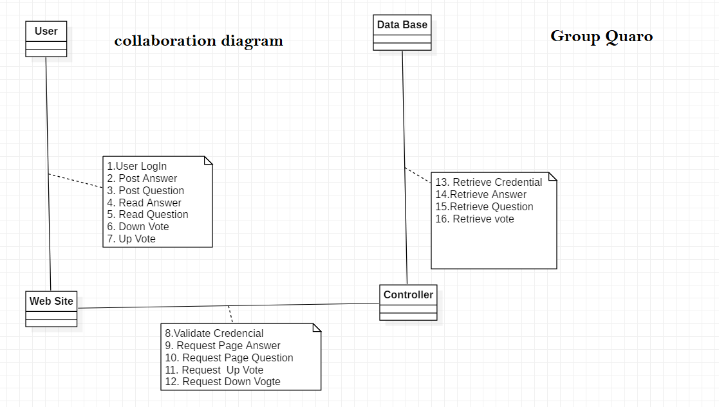

**VOPC diagrams**

Sign Up

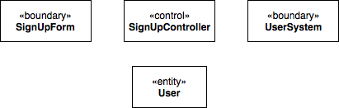

Login

Post question

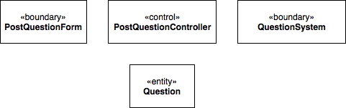

Answer question